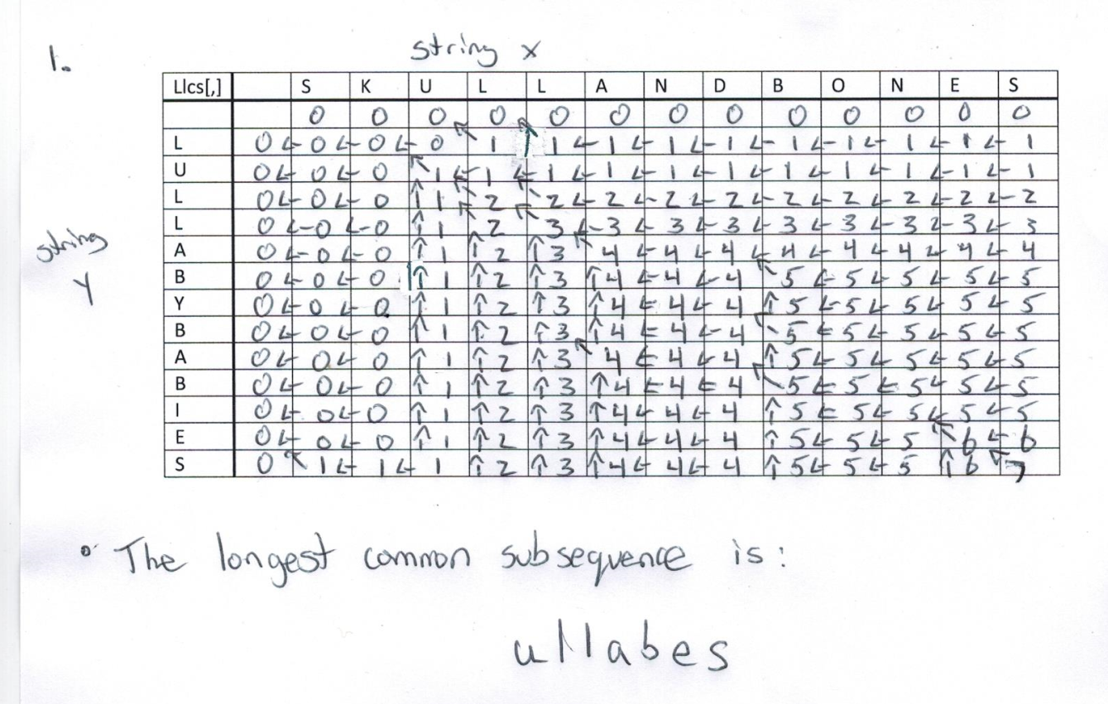

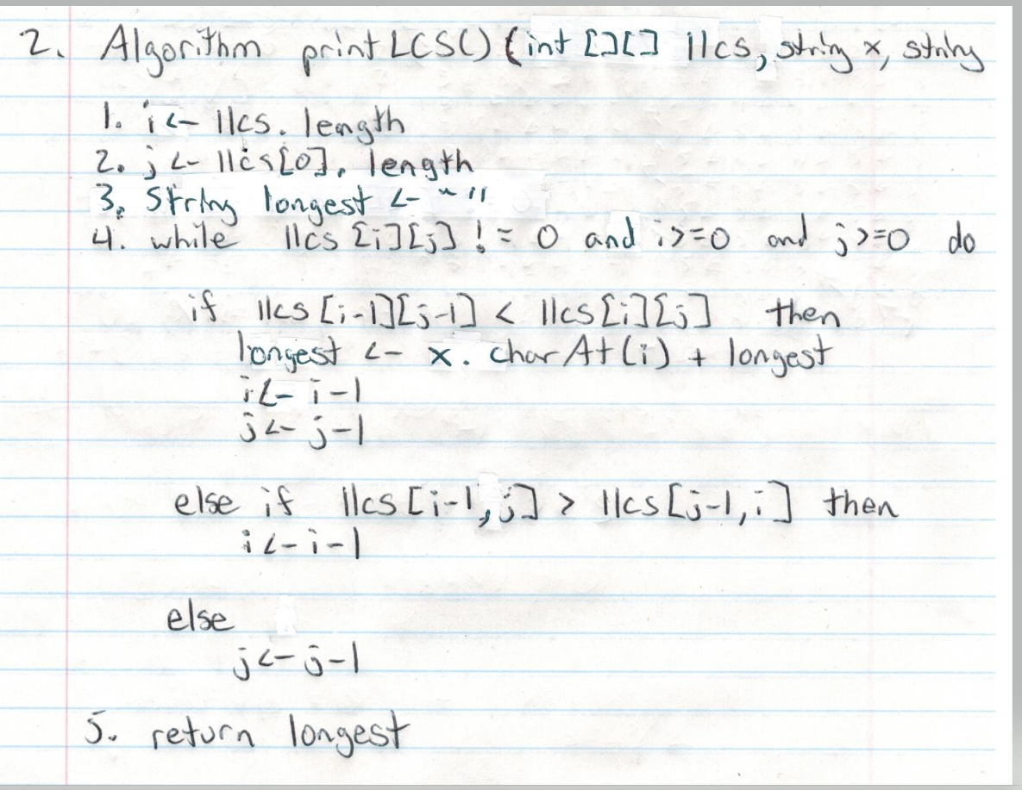

We can see here that the algorithm runs in O(n+m) time. Each time the while loop runs there are 3 possibilities. In the very worst case the if statement never occurs and each else statement is run to their fullest extent. This would mean that the else if statement would run i times, and the else statement would run j times. This gives us O(i + j) which equates to O(n+m)

**3.**

|  |  |  |  |  |  |  |  |  |  |  |  |  |  |
| --- | --- | --- | --- | --- | --- | --- | --- | --- | --- | --- | --- | --- | --- |
|  |  | A | B | R | A | C | A | D | A | B | R | A |  |
| **c** | -1 | 0 | 1 | 2 | 3 | 4 | 5 | 6 | 7 | 8 | 9 | 10 | **Right[c]** |
| A | -1 | 0 | 0 | 0 | 3 | 3 | 5 | 5 | 7 | 7 | 7 | 10 | 10 |
| B | -1 | -1 | 1 | 1 | 1 | 1 | 1 | 1 | 1 | 7 | 7 | 7 | 7 |
| C | -1 | -1 | -1 | -1 | -1 | 4 | 4 | 4 | 4 | 4 | 4 | 4 | 4 |
| D | -1 | -1 | -1 | -1 | -1 | -1 | -1 | 6 | 6 | 6 | 6 | 6 | 6 |
| R | -1 | -1 | -1 | 2 | 2 | 2 | 2 | 2 | 2 | 2 | 9 | 9 | 9 |

**4.**

|  |  |  |  |  |  |  |  |  |  |  |  |
| --- | --- | --- | --- | --- | --- | --- | --- | --- | --- | --- | --- |
|  | 0 | 1 | 2 | 3 | 4 | 5 | 6 | 7 | 8 | 9 | 10 |
|  | **A** | **B** | **R** | **A** | **C** | **A** | **D** | **A** | **B** | **R** | **A** |
| **A** | 1 | 1 | 1 | 4 | 1 | 6 | 1 | 8 | 1 | 1 | 11 |
| **B** | 0 | 2 | 0 | 0 | 2 | 0 | 2 | 0 | 9 | 0 | 0 |
| **C** | 0 | 0 | 0 | 0 | 5 | 0 | 0 | 0 | 0 | 0 | 0 |
| **D** | 0 | 0 | 0 | 0 | 0 | 0 | 7 | 0 | 0 | 0 | 0 |
| **R** | 0 | 0 | 3 | 0 | 0 | 0 | 0 | 0 | 0 | 10 | 0 |

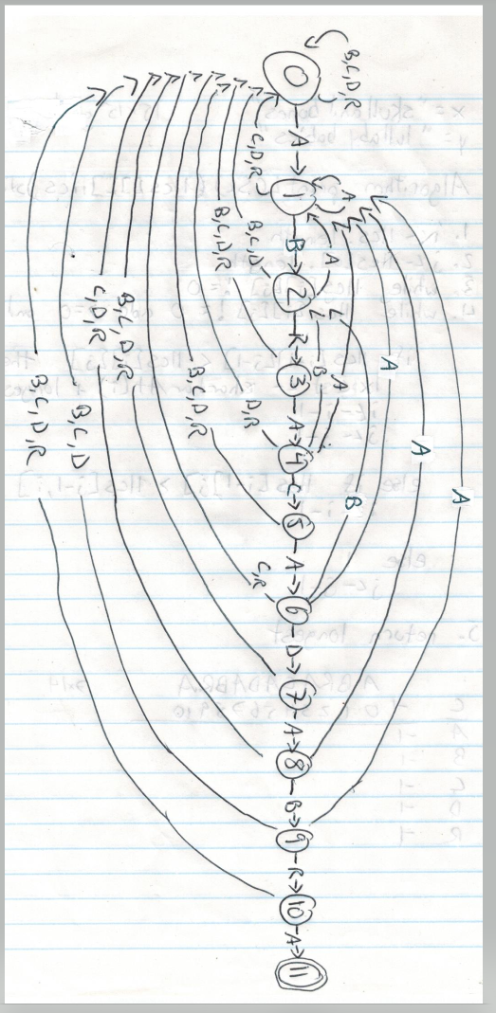

**5.**

